Task 11.5 - Safety & Compliance Dashboard Documentation

Objective:
The main objective of the dashboard is to monitor, analyze, and improve workplace safety by tracking incidents, injuries, near misses, and lost work hours across different sites and business units.
The dashboard helps management identify high-risk locations, injury types, and trends so they can take preventive actions to reduce accidents.

Dataset Overview:
The dataset contains safety-related information from multiple company sites and business units.
Key Columns Explanation:
Columns | Description
Date | Date when the incident occurred
Site | Location where incident happened
Business Unit | Department (Transport, Production, Maintenance, etc)
Incidents | Total number of incidents
Near Miss | Events that could have caused accidents but did not
Injuries | Number of injuries occured
Vehicle | Accidents involving vehicles
Lost Hours | Total work hours lost due to incidents
Severity | Incident seriousness (Critical, Major, Minor)
Most Frequent Injury | Common injury type (Arm, Back, Foot, etc).

KPI cards key performance indicator:
The KPI can't show overall safety performance.
Includes:
- Total Incidents → 6K
- Total Injuries → 2K
- Total Near Miss → 2K
- Total Lost Hours → 291
- Total Vehicle Incidents → 920.
If a factory has 6000 incidents in a year. It means safety improvement is
required urgently. Management can use this information to implement
safety training programs.

Total Incidents by Severity (Donut Chart)
This chart shows distribution of incidents by severity:
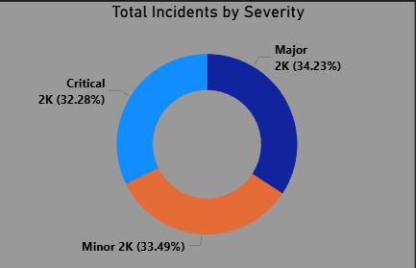
- Critical incidents
- Major incidents
- Minor incidents

If Critical incidents increase, it means employees are facing serious danger,
and management must take immediate action.
Machine safety guards may be missing.

Total Injuries by Most Frequent Injury (Tree Map)
This chart shows which body parts are most affected.
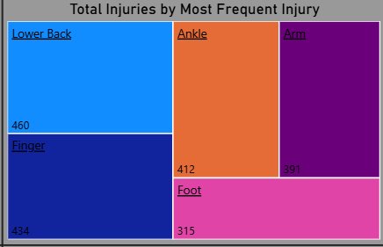
- Lower Back
- Finger
- Ankle
- Arm
- Foot
If the lower back is highest, it indicates improper lifting techniques.
Machine safety guards may be missing.

Total Injuries by Business Unit (Bar Chart)
This shows which department has the highest incidents.
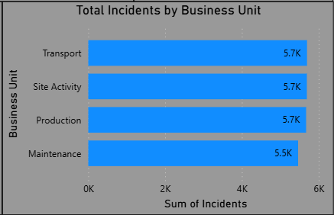
- Transport
- Site Activity
- Production
- Maintenance
Transport drivers may face more risks due to vehicle operation. Management can
improve driver training and vehicle maintenance.

Total Incidents by Site (Bar Chart)
Shows which location has the highest incidents.
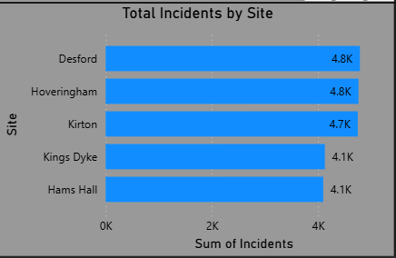
- Desford
- Hoveringham
- Kirton
- Kings Dyke
- Hams Hall
Desford site may have unsafe working conditions.
Management can inspect the site and improve safety standards.

Total Incidents by Year (Line Chart)
Show incident trends over time.
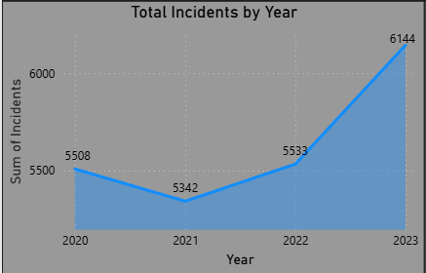
Increase in incidents may indicate:
- New employees without training
- Poor supervision
- Increased workload

Total Incidents & Near Miss by Year (Clustered Column Chart)
Compares incidents and near misses.
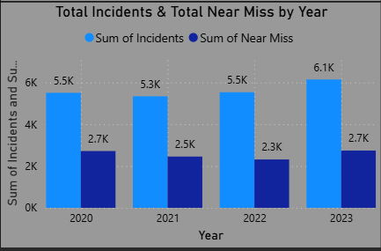
Near miss is important because it shows potential future accidents. If near
misses increases, accidents may increase later.
Management can fix risks early.

Slicers (Filters)
Slicers allow users to filter data by:
- Date
- Site
- Business Unit
- Severity
The manager can filter the dashboard for Transport department safety
performance.

Dashboard can help real life cases:
- Improve employee safety
- Identify unsafe locations
- Identify high risk departments
- Identify common injury types
- Monitor incidents trends
- Take preventive safety actions and Reduce accidents
- Reduce accidents and improve safety
- Reduce financial losses

Conclusion:
The Safety & Compliance Dashboard is a powerful tool for monitoring workplace
safety performance.
It helps organizations:
- Identify safety risks
- Prevent accidents
- Improve employee safety
- Make better business decisions
By using this dashboard, companies can create a safer working environment and improve operational efficiency.

